**Spatial Variation in Soundscape using Clustered Drifting Recorders**

Kaitlin Palmer

Anne Simonis

**Background**

Understanding and reporting ambient noise levels is a crucial part of all passive acoustic studies. Ambient noise levels can influence local marine life, sometimes adversely, and introduce bias into density, abundance, or occupancy estimates. Within the context of BOEMs wind energy areas (WEA), there is a concerted effort to understand whether and how ambient noise levels change between the baseline, construction, and operational phases of offshore wind farms and how this may affect different species present in the region. These baseline data are critical to monitor changes in sound levels from anthropogenic sources in space and time as activities related to offshore wind development increase in the WEAs.

Sound pressure levels vary as a function of three-dimensional location as well as time. Vertical placement of sensors will lead to different propagation conditions due to the temperature profile and thermocline, through surface and bottom reflections, and proximity to noise sources. Understanding the spatial extent of noise is a particularly challenging question for PAM studies that rely on a single sensor or sparse array of sensors to monitor large habitat regions. Some of the principal questions needing to be addressed include, are the noise levels measured at a given hydrophone representative of those experienced by the species monitored? How do assumptions about frequency bands and integration periods (e.g. minutes vs. hours) vary over space?

**Research Objective:** The ADRIFT project uses clusters of drifting buoys to produce snapshots of ambient noise levels and animal presence in wind energy areas that compliment existing longitudinal studies from nearby seafloor hydrophones. With these buoys, we can begin to document spatial variability in soundscapes, validate propagation models, and better understand how well single sensors represent sound within the greater region. The following work highlights some of the preliminary findings of noise representation from the ADRIFT project.

**Spatial Cohesion**

The first preliminary analysis we have undertaken is the spatial cohesion of ambient noise levels across an array of 7 drifters. We ask, ‘how similar are the fluctuations in noise levels between spatially dispersed drifters?’. Figure 1 shows the 2-minute median noise level in two third octave bins during an 8 day drift in the Morro Bay WEA. Considerable variation in noise levels were observed in the first few days across both third octave bins with more variation, as expected, in the 20 kHz bin. Interestingly, storms moving through the area during the second half of the deployment raised the baseline noise levels nearly uniformly.

**Figure 1** Time series of noise levels recorded by the drifters in the 500 Hz third octave bin (top) and the 20 kHz third octave bin (bottom).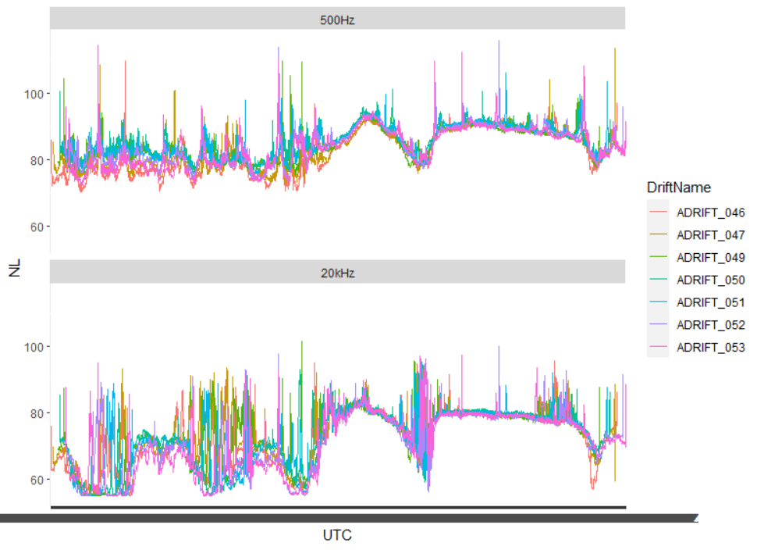

The cohesion of these noise levels can be quantified using correlation scores. Correlation scores measure the strength and direction of the linear relationship between multiple measurements. Scores range from -1, indicating a perfectly inverse relationship between noise levels at different locations, and +1 indicating a perfect and positive correlation between noise levels at different locations. In order to assume that noise levels are similar across the study area, we would expect correlation scores between all instruments at or approaching 1.

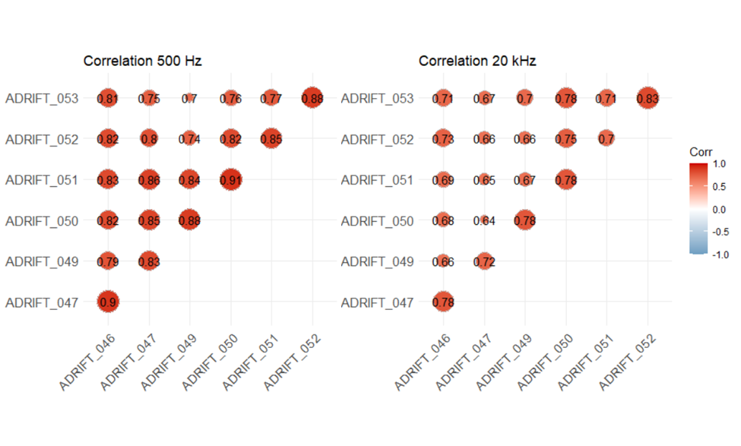

**Figure 2**. Correlation scores across the Morro Bay March 2023 drifting period in the 500 Hz third octave bin (left) and the 20 kHz third octave bin (right)

Figure 2 shows positive correlation between all drifters within the region with scores ranging between 0.7 and 0.91 in the 500 Hz band and 0.64 and 0.83 in the 20 kHz band. This indicates that, on average, noise levels were somewhat correlated over the deployment and that noise levels from more closely spaced units were more highly correlated, as expected. Much of this correlation is attributed to the regional scale storms that uniformly affected the area.

Because the data from the drifters inherently cover both space and time, we can use the fields package in R to model sound levels across the entire region (Figure 3). This image represents the ambient noise levels in the period before the storm, with sound levels in the northwest region being several dB higher than those in the eastern region.

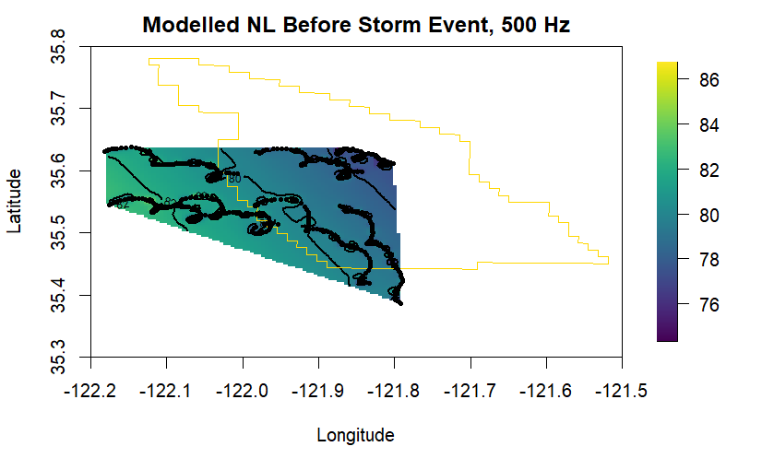

Figure 3. Noise map of the 500 Hz band before the storms. Gold outline indicates the wind energy area and black points show the path of the drifters before the onset of the storm. All drifters started at the northern portion of their paths and traveled south/southeast.

**Future Directions**

This preliminary exploration of the data highlights some interesting spatial aspects of noise that warrant further investigation. Future analyses may include:

1. Evaluate noise levels as a function of distance between sensors

Correlation in noise levels can be investigated as a function of distance between sensor pairs throughout the deployment. Quantifying this relationship will help to validate propagation models and improve future estimates of noise levels from disparate sensors once wind farms are operational.

1. Parse environmental and anthropogenic contributions to noise levels

Depth-dependent empirical models for wind-generated noise can be applied to drifting recorders ([Carey and Evans, 2011](https://books.google.com/books?hl=en&lr=&id=dEoSXWzg8AQC&oi=fnd&pg=PR9&ots=30nbCAmedb&sig=p8fprQ9AbdS0MaAYTwYwDSntqDU#v=onepage&q&f=false), [Hildebrand et al 2021](https://pubs.aip.org/asa/jasa/article/149/6/4516/1059383/An-empirical-model-for-wind-generated-ocean-noise)). Once the wind-component of noise is subtracted from sound levels, sound maps (like Figure 3) can be used to evaluate changes in biological and anthropogenic activity throughout the study area.

1. Evaluate depth-dependent changes in ambient noise levels

Sound levels recorded near the surface by drifting recorders can be compared with bottom-moored sensors to measure depth dependent changes in ambient noise levels. This is particularly relevant if future acoustic monitoring is limited to seafloor sensors, which do not occupy the predominant habitat of most marine mammals, or sensors that modulate their depth throughout the survey period (e.g. gliders).